**G:\2017-18\SCHOOL ALL OVER\BODHI LOGO.jpgVELAMMAL BODHI CAMPUS**

**(A CBSE – IIT/NEET Integrated Sr. Sec. School)**

**Class: X Grand Test- 3 Marks: 80**

**Sub: Maths Duration: 3 hours**

**General Instructions:**

**1. This Question Paper has 5 Sections A ⎼ E.**

**2. Section A has 20 MCQs carrying 1 mark each**

**3. Section B has 5 questions carrying 02 marks each.**

**4. Section C has 6 questions carrying 03 marks each.**

**5. Section D has 4 questions carrying 05 marks each.**

**6. Section E has 3 case based integrated units of assessment (04 marks each).**

**7. All Questions are compulsory. However, an internal choice in 2 Qs of 5 marks, 2 Qs of 3 marks and 2 Questions of 2 marks has been provided. An internal choice has been provided in the 2marks questions of Section E**

**8. Draw neat figures wherever required. Take π =22/7 wherever required if not stated.**

**SECTION - A**

**I. ANSWER THE FOLLOWING QUESTIONS: 20X 1 = 20**

1. Write the exponent of 3 in the prime factorisation of 1944.

(a) 3 (b) 1 (c) 5 (d) 4  
2. The zeroes of the quadratic polynomial x² – 15x + 50 are

(a) both negative (b) one positive and one negative  
 (c) both positive (d) both equal

3. A real number α is a zero of the polynomial f (x) if:

(a) f (α) > 0 (b) f (α) < 0 (c) f (α) = 0 (d) f (α) ≥ 0

4. If the system of equations 3x + y = 1 and (2k – 1)x + (k – 1)y = 2k + 1 is

inconsistent, then k =

(a) -1 (b) 0 (c) 1 (d) 2

5. If the nth term of an AP is (2n +1), then the sum of its first three terms is  
 (a) 6n + 3 (b) 15 (c) 12 (d) 21

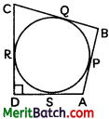6. In the figure ∠ADC = 90°, BC = 38 cm, CD = 28 cm and BP = 25 cm. The radius of the circle is:

(a) 20 cm (b) 15 cm

(c) 16 cm (d) 18 cm

7. In given figure, CP and CQ are tangents to a circle with centre O. ARB is another tangent touching the circle at R. If CP = 11 cm and BC = 6 cm then the 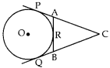length of BR is

(a) 6 cm (b) 5 cm (c) 4 cm (d) 3 cm

8. **Two vertices of a triangle are (3, – 5) and (- 7,4). If its centroid is (2, -1), then the third**

**vertex is**

(a) (10, 2) (b) (-10,2) (c) (10,-2) (d) (-10,-2)

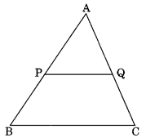9. In the figure PQ || BC. If PQ/BC = 2/5 then AP/ PB is

(a) 2/5 (b) 2/3 (c) 3/2 (d) 3/5

10. The value of

(a) (b) $-2-\sqrt{3}$ (c) $\sqrt{3}- 2$ (d) None of these

11. If sin (A- B) = 0.5, cos (A + B) = 0.5 ; 0° < A + B ≤ 90°, ∠A > ∠B then, values of ∠A and ∠B are:

(a) ∠A = 45°, ∠B = 15° (b) ∠A = 55°, ∠B = 25°

(c) ∠A = 35° , ∠B = 25° (d) None of these.

12. The angle of depression of a car, standing on the ground, from the top of a 75 m high

tower is 30°. The distance of the car from the base of tower (in m) is:  
 (a) 25√3 (b) 50√3 (c) 75√3 (d) 150

13. In a circle of radius 14cm, an arc subtends an angle of 30° at the centre, the length of the arc is

(a) 44 cm (b) 28 cm (c) 11 cm (d) 22/3 cm

14. What is the formula for the median of Grouped data?  
 a) Median = L + [(n / 2 – cf) / f] * h (b) Median = L + [(n / 2 + cf) / f] * h  
 c) Median = L + [(n / 2 – cf) / f] + h (d) Median = L * [(n / 2 – cf) / f] * h  
15. The edge of the cube whose volume is 1728cm is

(a) 17cm (b) 12cm (c) 18cm (d) 72cm

16. What is the common difference of an AP in which a21 – a7 = 84?  
 (a) 7 (b) 12 (c) 8 (d) 6

17. If two dice are thrown together, what is the probability of getting an even number on one dice and an odd number on the other dice?

(a) ¼ (b) 3/5 (c) ¾ (d) ½

18. The letters of the word SOCIETY are placed at random in a row. The probability of getting a vowel is

(a) $\frac{1}{7}$ (b) $\frac{2}{7}$ (c) $\frac{3}{7}$ (d) $\frac{4}{7}$

**Direction:** In the question number 19 and 20, a statement of assertion (A) is followed by a statement of reason (R).  
Choose the correct option as:  
(a) Both assertion (A) and reason (R) are true and reason (R) is the correct explanation of assertion (A)  
(b) Both assertion (A) and reason (R) are true and reason (R) is not the correct explanation of assertion (A)  
(c) Assertion (A) is true but reason (R) is false.

(d) Assertion (A) is false but reason (R) is true.

19. Statement A (Assertion): (cos4A – sin4 A) is equal to 2cos2 A – 1.  
 Statement R (Reason): The value of cos θ decreases as θ increases.

20. Statement A (Assertion): If the length of the minute hand of a clock is 7 cm, then the

area swept by it in 5 minutes is  cm2.  
 Statement R (Reason):  The length of an arc of a sector of angle θ and radius r is

given by $l=\frac{θ}{360°}×2πr$ .

**SECTION - B**

**II. ANSWER THE FOLOWING QUESTIONS: 5 X 2 = 10**

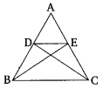21. Three bells toll at intervals of 12 minutes, 15 minutes and 18 minutes respectively. If they start tolling together, after what time will they next toll together?

22. (a) In the given figure, if ∆ABE ≅ ∆ACD, show that ∆ADE ~ ∆ABC.

(OR)

(b) D is a point on the side BC of a triangle ABC, such that ∠ADC = ∠BAC. Show that CA² = CB.CD.

23. Given 15 cot A = 8, find sin A and sec A.

24. A quadrilateral ABCD is drawn to circumscribe a circle (see figure). Prove that

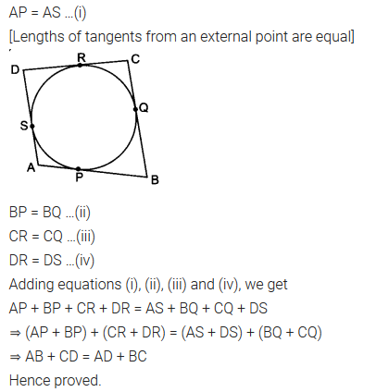 AB + CD = AD + BC.

25. (a) The minute hand of a clock is 10 cm long. Find the area of the face of the clock

described by the minute hand between 9 AM and 9.35 AM.  
 (OR)

**(b) A car has two wipers which do not overlap. Each wiper has a blade of length 25 cm sweeping through an angle of 115°. Find the total area cleaned at each sweep of the blades.**

**SECTION – C**

**III. ANSWER THE FOLOWING QUESTIONS: 6X 3 = 18**

26**.** Prove that √7 is an irrational number.  
27. If α and β are the zeroes of the quadratic polynomial 2x2 – 3x + 1, find a quadratic

polynomial whose zeroes are 3α and 3β.

28. (a) **Graphically, solve the following pair of equations: 2**x **+**y **= 6 ; 2**x **–**y **+ 2 = 0**

**Find the ratio of the areas of the two triangles formed by the lines representing these**

**equations with the**x**-axis and the lines with the**y**-axis.**

(OR)

**(b) For which values of**a **and**b **will the following pair of linear equations have infinitely many solutions?** x + 2y = 1; (a-b)x + (a + b)y = a + b – 2.

29. (a) Prove that:

(OR)

(b) Find the value of

30. In figure, XY and X’Y’ are two parallel tangents to a circle, with centre O and another

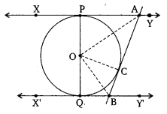 tangent AB with point of contact C intersecting XY at

A and X’Y’ at B. Prove that ∠AOB = 90°.

31. Cards numbered from 11 to 60 are kept in a box. If a card is drawn at random from the

box, find the probability that the number on the drawn card is:  
(i) an odd number. (ii) a perfect square number. (iii) a prime number less than 35

**SECTION – D**

**III. ANSWER THE FOLOWING QUESTIONS: 4 X 5 =20**

32. State and Prove Thales Theorem. Using above theorem, if DE || OQ and

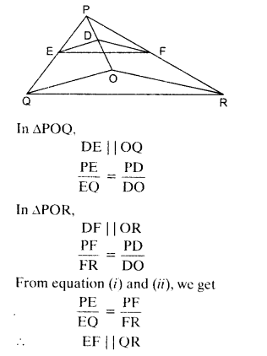 DF || OR. Show that EF || QR.

33. If the roots of the quadratic equation (a – b) x2 + (b – c) x + (c – a) = 0 are equal,

prove that 2a = b + c.

34. (a) From a solid cylinder whose height is 2.4 cm and diameter 1.4 cm, a conical cavity of the same height and same diameter is hollowed out. Find the total surface area of the remaining solid to the nearest cm?

**(OR)**

(b) A gulab jamun, contains sugar syrup about 30% of its volume. Find approximately how much syrup would be found in 45 gulab jamuns, each shaped like a cylinder with two hemispherical ends with length 5 cm and diameter 2.8 cm.

35. Find the values of f1 and f2 of the frequency, if the mean of the following frequency

distribution is 21.4 and the total frequency is 40.

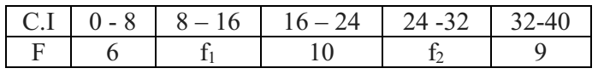

**SECTION-E**

**CASE STUDY QUESTIONS: 3X4=12**

**36.** A group of students of class X visited India Gate on an education trip. The teacher and students had interest in history as well. The teacher narrated that India Gate, official name Delhi Memorial, originally called All-India War Memorial, monumental sandstone arch in New Delhi, dedicated to the troops of British India who died in wars fought between 1914 and1919. The teacher also said that India Gate which is located at the eastern end of the Rajpath, is about 138 feet(42 metres) in height.

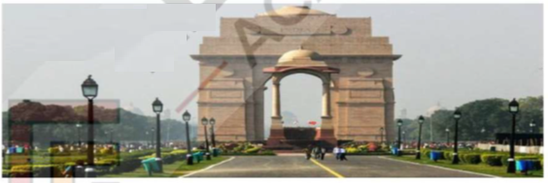

(i) What is the angle of elevation if they are standing at a distance of 42 m away from the monument?

(OR)

The ratio of the length of a rod and its shadow $\sqrt{3}:1$. Find the angle of elevation of the

sun?

(ii) If the altitude of the Sun is at 60°, then find the height of the vertical tower that will cast a shadow of the length 20 m?

(iii) They want to see the tower at an angle 60°. So, they want to know the distance where they should stand and hence find the distance.

37. Your elder brother wants to buy a car and plans to take loan from a bank for his car. He repays his total loan of Rs. 1,18,000 by paying every month starting with the first

installment of Rs. 1000. If he increase the installment by Rs.100 every month, answer the following:

1. Find the amount paid by him in 30th installment?

(OR)

Find the ratio of the first installment to the last installment?

2. Find the total amount paid by him up to 30 installments ?

3. What amount does he still have to pay after 30th installment?

38. **Read the case study carefully and answer the following questions:**

Mary and John are very excited because they are going to go on a dive to see a sunken ship. The dive is quite shallow which is unusual because most sunken ship dives are found at depths that are too deep for two junior divers. However, this one is at 40 feet, so the two divers can go to see it.



They have the following map to chart their course. John wants to figure out exactly how far the boat will be from the sunken ship. Use the information in this lesson to help John figure out the following.

(i) Find the shortest distance (in the map) between the boat and the sunken ship?

(OR)

Find the coordinates of the boat and the sunken ship?

(ii) Find the coordinate of the midpoint, If we join the coordinates of the sunken ship and the boat?

(iii) If the distance between the points (x, -1) and (3, 2) is 5, then find the value of x?